Git hub error rectifications:
Readme.md file was already created in repository so that why this error
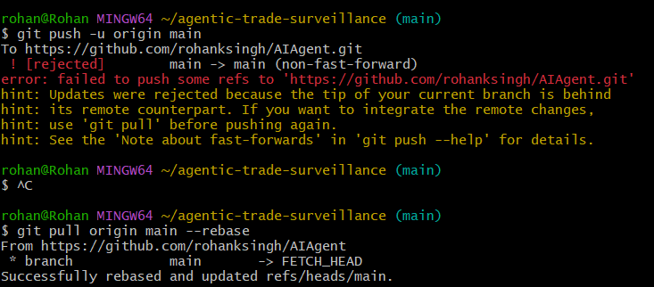
Resolved error screenshot:
